LAB 10 A-1

CODE

//
// main.cpp
// lab9
//
// Created by Ricardo Santos on 5/2/19.
// Copyright © 2019 Ricardo Santos . All rights reserved.
//

//
// main.cpp
// LAB 9 Ricardo Santos
//
// Created by Ricardo Santos on 5/1/19.
// Copyright © 2019 Ricardo Santos . All rights reserved.
//

#include <iostream>
#include <string>
#include <cctype>
#include <cstring>
#include <cstdlib>

using namespace std;

struct DATE
{
int day;
string month;
int year;
};

int main()
{
DATE todaysdate = {3, "May", 2019};
DATE FAVDate;

cout << "What is your favorite day?\n";
cin >> FAVDate.day >> FAVDate.month >> FAVDate.year;

cout << "Today's date is: " << todaysdate.day << "" << todaysdate.month << "" << todaysdate.year;

cout << "My favorite date is: " << FAVDate.day << "" << FAVDate.month << "" << FAVDate.year << endl;

if(todaysdate.month == FAVDate.month)
{
cout << "We are in your favorite month\n";

}
else
cout << "This is not yoru favorite month\n";
return 0;
}

OUTPUT

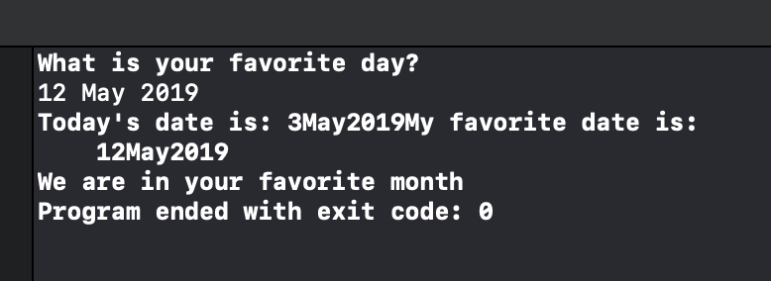

LABB 10A – 2

//
// main.cpp
// lab9
//
// Created by Ricardo Santos on 5/2/19.
// Copyright © 2019 Ricardo Santos . All rights reserved.
//

//
// main.cpp
// LAB 9 Ricardo Santos
//
// Created by Ricardo Santos on 5/1/19.
// Copyright © 2019 Ricardo Santos . All rights reserved.
//

#include <iostream>
#include <string>
#include <cctype>
#include <cstring>
#include <cstdlib>
#include <iomanip>

using namespace std;

const int NUMworkers = 3;

struct PersonalTAX
{
string name;
float annualSAL, taxRate, taxowe;
};

int main()
{
PersonalTAX worker[NUMworkers];
int i;

for(i=0; i< NUMworkers; i++)
{
cout << "Worker #"<< (i+1) << " name: ";
cin.ignore();
getline(cin, worker[i].name);

cout << "Worker #" << (i+1) << " salary: ";

cin >> worker[i].annualSAL;

cout << "Worker #" << (i+1) << " tax rate: ";
cin >> worker[i].taxRate;

cout << endl;
}

cout << fixed << showpoint << setprecision(2);

for(i=0; i < NUMworkers; i++)
{
worker[i].taxowe = worker[i].annualSAL * worker[i].taxRate;

cout << "Worker #" << (i+1) << " should owe in taxes: $" << worker[i].taxowe << endl;

}
return 0;
}

OUTPUT

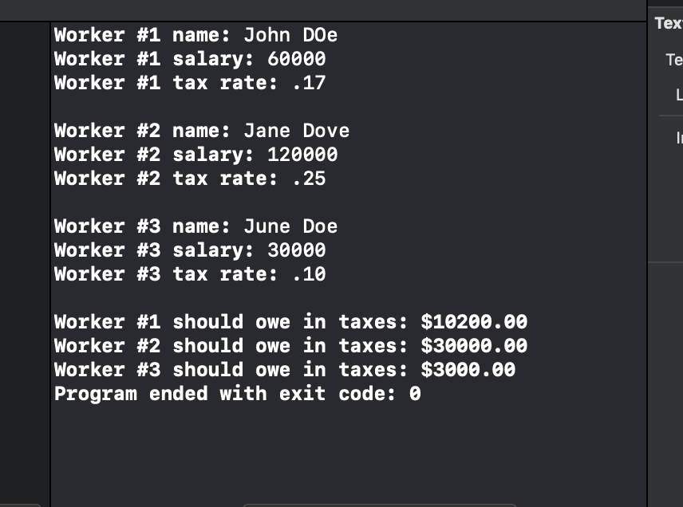

LAB 10A-3

CODE
//
// main.cpp
// lab9
//
// Created by Ricardo Santos on 5/2/19.
// Copyright © 2019 Ricardo Santos . All rights reserved.
//

//
// main.cpp
// LAB 9 Ricardo Santos
//
// Created by Ricardo Santos on 5/1/19.
// Copyright © 2019 Ricardo Santos . All rights reserved.
//

#include <iostream>
#include <string>
#include <cctype>
#include <cstring>
#include <cstdlib>
#include <iomanip>

using namespace std;

struct DIMENSIONS
{
int length;
int width;

};

struct RECTANGLE
{
int area;
int perimeter;
DIMENSIONS sizes;
};

DIMENSIONS GETDimensions();
int GETAREA(int, int);
int GETPERIMETER(int, int);
void GETINFO(const RECTANGLE &);

int main()
{
RECTANGLE input;
input.sizes = GETDimensions();
input.area = GETAREA(input.sizes.length,input.sizes.width);
input.perimeter = GETPERIMETER(input.sizes.length, input.sizes.width);
GETINFO(input);

return 0;
}

DIMENSIONS GETDimensions()
{
DIMENSIONS a;
cout << "Enter the length of a rectangle: ";
cin >> a.length;
cout << "Enter the width of a rectangle: ";
cin >> a.width;
return a;
}

int GETAREA(int x, int y)
{
return x * y;
}

int GETPERIMETER(int x, int y)
{
return 2*(x+y);
}

void GETINFO(const RECTANGLE &result)
{
cout << "Rectangle Area is " << result.area << endl;
cout << "Rectangle Perimeter is " << result.perimeter << endl;

}

OUTPUT

